Website design illustrations

1.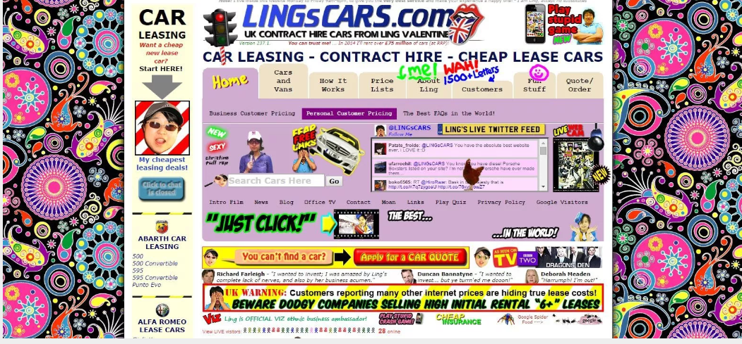

I did not pick this webpage design because:

This webpage has way too much colors and all the content is very cramped together. The over-all look of the webpage is not very user friendly.

2.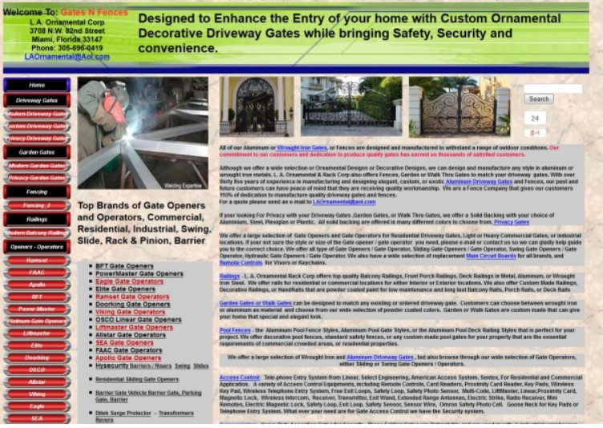

I did not pick this webpage design because:

There is way too much text displayed which can confuse some users. The navigation looks quite complicated plus the colors are unattractive.

3.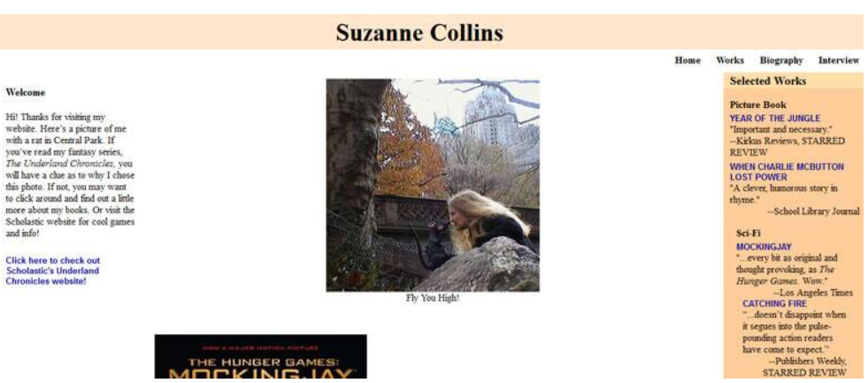

I did not pick this webpage design because:

The overall look of this website is very unattractive... The format of the pages are in a bad design and wouldn’t attract browsers much.